# Brain Tumor Detection using morphological operations

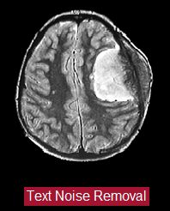

Step 1 Text removal

* Covert the image to graylevel
* Then convert it to binary image
* After that fill the holes
* Use ExtractNLargestBlobs

ExtractNLargestBlobs: this function takes 2 parameters the binary image and number of objects to extract and then return the chosen number of objects.

So if numberToExtract > 0 it returns the numberToExtract largest blobs. If numberToExtract < 0 it returns the numberToExtract smallest blobs. Example: return a binary image with only the largest blob: binaryImage = ExtractNLargestBlobs (binaryImage, 1); Example: return a binary image with the 3 smallest blobs: binaryImage = ExtractNLargestBlobs (binaryImage, -3);

We used this function to retrieve the whole brain without the text written down and write it.

Step 2 Make Enhancement for the image

In this step we are making enhancement for the received image from previous step with the following methods:

* Sharpening: returns an enhanced version of the grayscale image where the image features, such as edges, have been sharpened.
* Image adjust: increase the contrast (separation between the dark and white colors) of the image and saturate the high and low intensities.

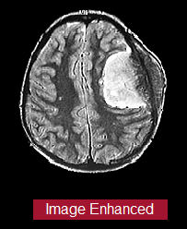

Step 3 Applying noise removal filters

In this step we try many Image processing filters like min, max, median and mean and here are the result for each filter in the final image.

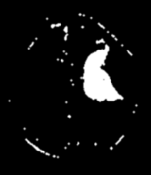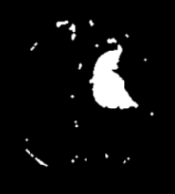

Min Filter Max Filter Median Filter Mean Filter

Step 4 Make thresholding and segmentation

This step concerns with image analysis technique segmentation portioning the image into a foreground and background, so we can isolate the needed object by converting the image into black and white (binary image).

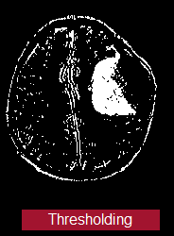

Step 5 Watershed Segmentation

This technique used for image segmentation and object separation.

Step 6 morphological operations

In this steps we used opening which is consists of two operation erosion followed by dilation we selected the opening operation as it is spot and noise removal and less destructive, and after that applied Gaussian filter to smooth the final image and here are the 2 result.

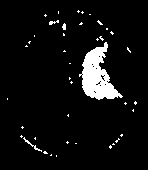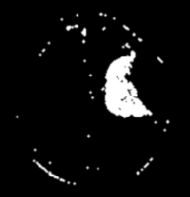

Final Image without gauss. Final Image using gauss.